|  |  |
| --- | --- |
| **Soal Praktikum**  *Practicum Case* |  |
| ISYS6028  Database Systems |
| **Teknik Informatika**  *Computer Science* | O221-ISYS6028-DW01-01 |
| **Periode Berlaku Mulai** Semester Ganjil 2017/2018  ***Valid on*** *Odd Semester Year* 2017/2018 | **Revisi 00**  *Revision 00* |

## Learning Outcomes

* Describe database systems, terminology, environment, and new concept of database

## Topic

* + - Session 01 - Database Environment

## Sub Topics

* Introduction general environment of SQL Server
* New Server Registration & New Group
* Diagram
* Attach Database
* Import & Export Data
* Generate SQL Script
* Execution SQL Statement

## Soal

*Case*

1. **Introduction to SQL Server 2012**

Microsoft SQL Server 2012 is a tool that allow us to organize database. Besides Microsoft SQL Server 2012, there are many other tools to organize database, for example: *Oracle*, *Postgress*, *MySQL*, etc.

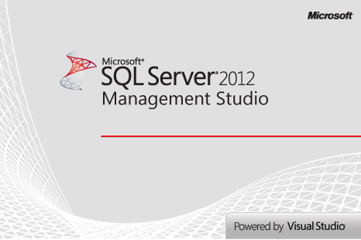

The following image is the main screen of SQL Server 2012:

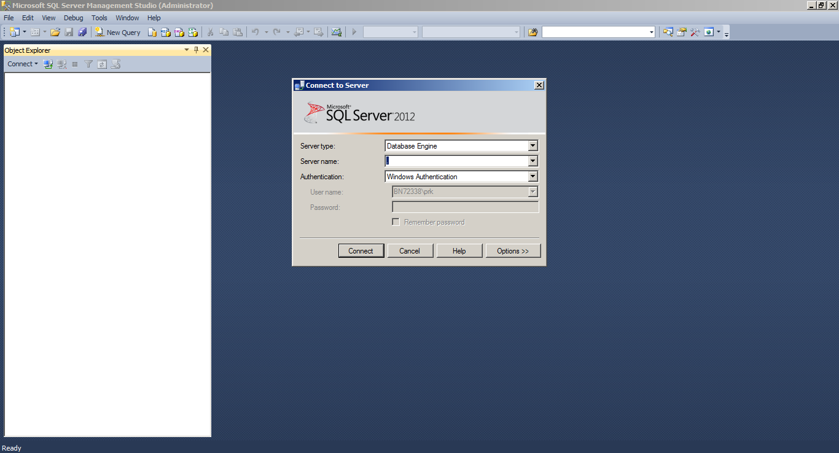

On the main screen, in **Connect to Server** dialog box there are **Server Types**, **Server Name**, and **Authentication**.

***Server type:***

* *Database Engine*
* *Analysis Service*
* *Reporting Service*
* *SQL Server mobile*
* *Integration Service*

***Server name:***

Server name describe the server that we used to connect to the SQL Server.

***Authentication*:**

There are two types of authentication in SQL Server, **Windows Authentication** and **SQL Server Authentication**.

1. **New Server Registration**

There are two types of registered server, *local server groups* and *central management server*. Frequently access servers are stored in *Management Studio on Registration*. In *SQL Management Studio* you can create, modify or remove registered server.

Registered server can be view on the **View** menu, and then click **Registered Servers**.

To **create a new server**, do the following steps:

1. Click **Database Engine** on Registered Server toolbar.
2. Right click on the **Local Server Groups** tree, and then click **New Server Registration**.

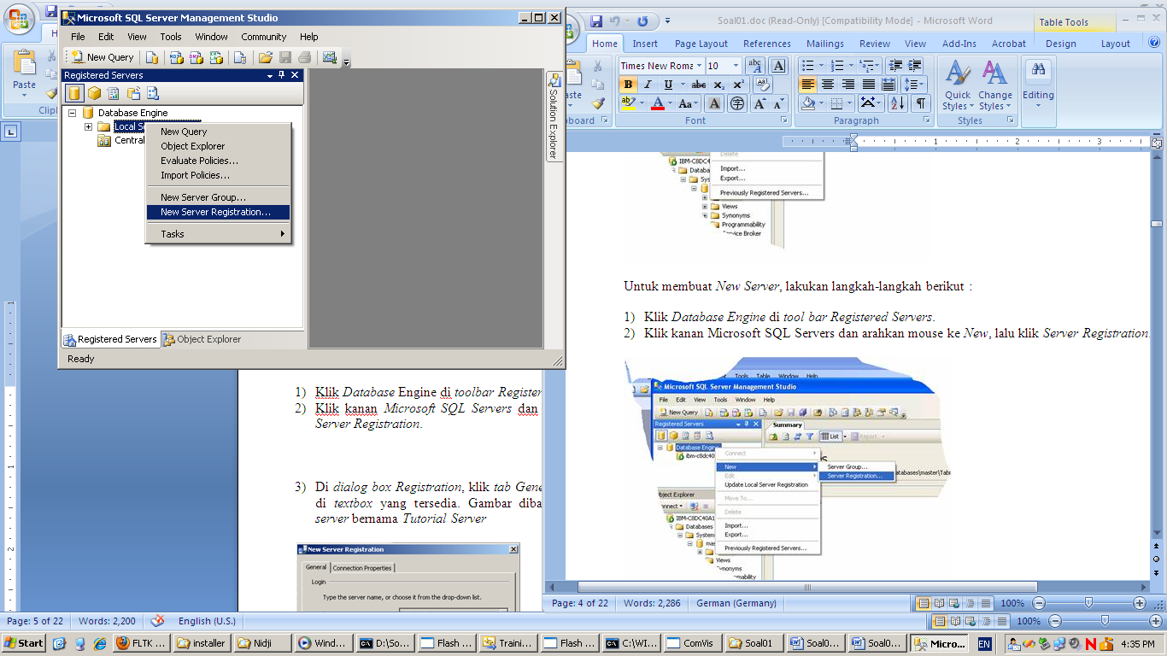

1. On the **New Server Registration** dialog box there are Server Type, Server Name, Authentication, Username, Password, Registered Server Name, and Registered Server Description.
   * + - **Server name**, select the server instance to register in the format <servername>[\<instancename>].
       - **Authentication,** there are two kinds of authentication modes, **Window Authentication** and **SQL Server Authentication**, that are available when connecting to an instance of SQL Server. Meanwhile **Windows Authentication** allows a user to connect through a Microsoft Window user account, **SQL Server Authentication** performs the authentication when a user connects with a specified login name and password from a nontrusted connection.
       - **Username**, shows the current user name you are connecting with. This option only available if you have selected to connect using Windows Authentication.
       - **Login**, enter the login to connect with. This option only available if you have selected to connect using SQL Server Authentication.
       - **Password**, enter the password for the login. This option only available if you have selected to connect using SQL Server Authentication.
       - **Registered server name**, the server name that you want to appear in Registered Server.
       - **Registered server description**, an optional description for your registered server.

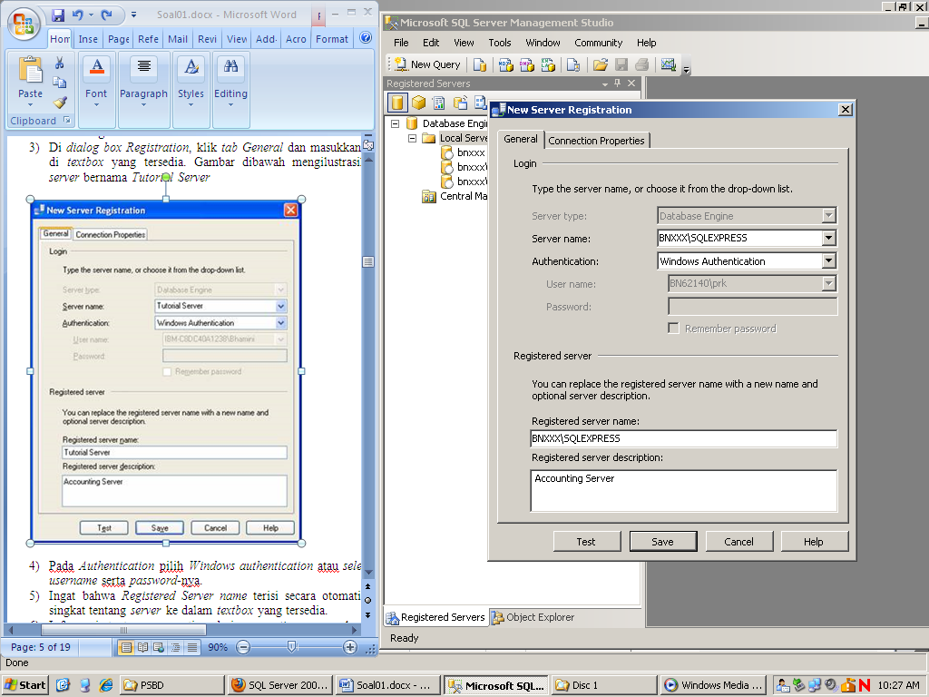

1. To test the connection to the server selected in server name, click **Test**. To save the registered server settings, click **Save**.

To **remove** the registered server, right click on the selected server and then click **Delete**,if confirmation dialog box appear click **Yes** to remove the server.

Server name can be modify anytime as long as it’s not affect the connection properties. To **modify** the server name, right click on the selected server and then click **Properties**, you can enter the new server name in the **Registered server name** textbox. To test the connection to the server selected in server name, click **Test**. To save the registered server settings, click **Save**.

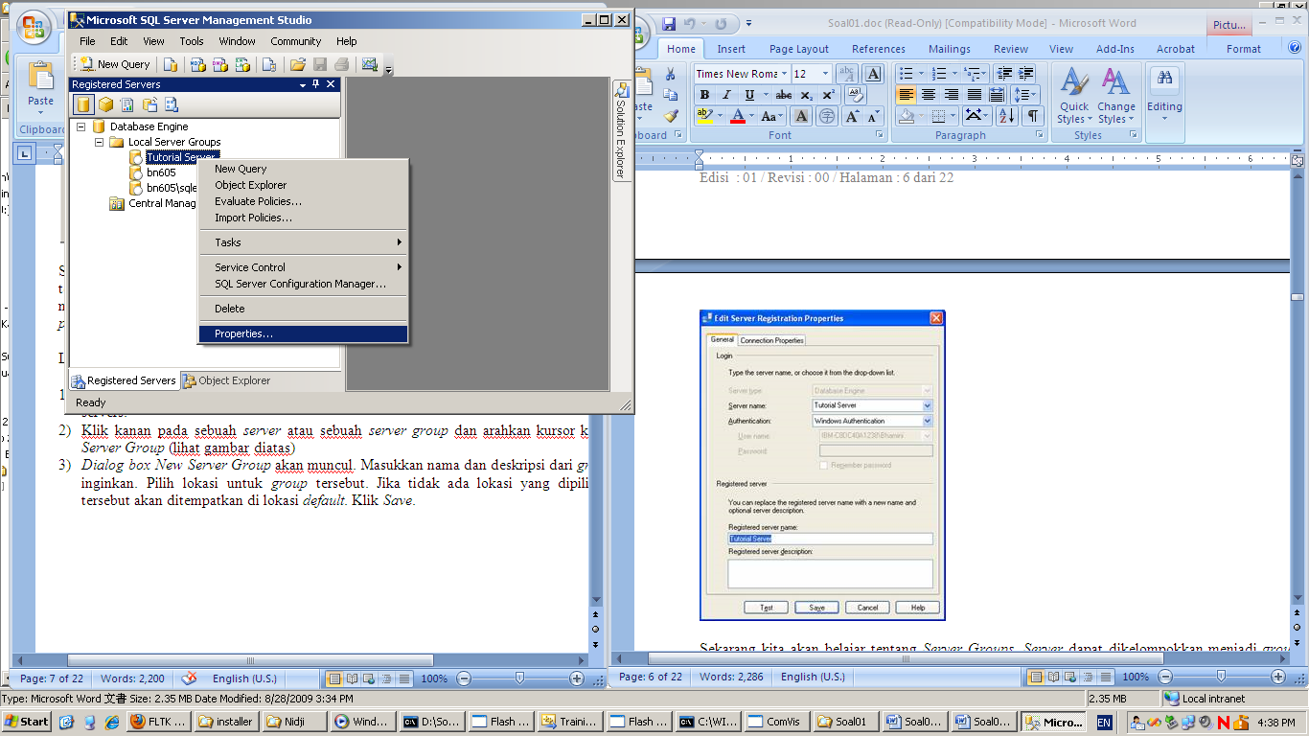

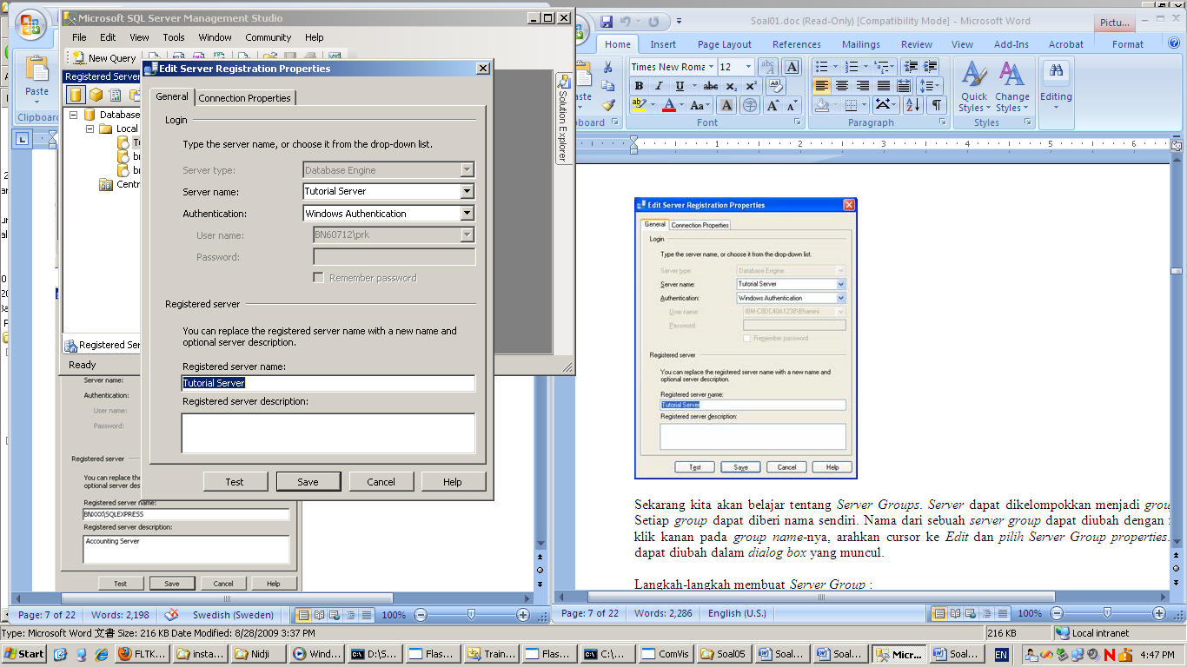

1. **New Group**

SQL Server Group is used to organize sets of computers running SQL Server. These groups can be organized by function or department. You can create subgroups within a group.

To create a server group (or a subgroup) do the following steps:

1. Right click on the selected server or server group, and then click **New Server Group**

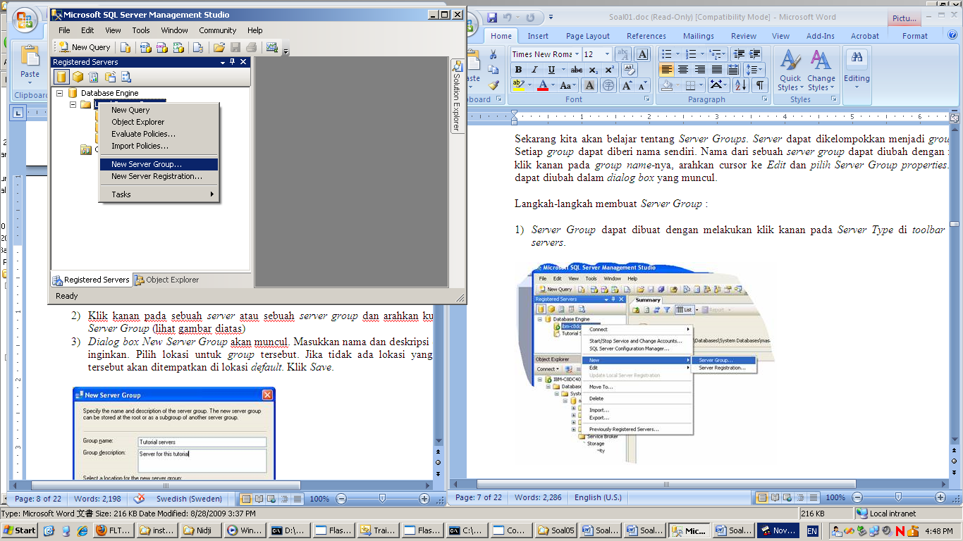

1. In the New Server Group dialog box, type a name and the description for the new group. Click **Save**.

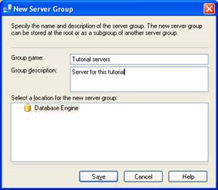

1. You can see the new server group in the Registered Server toolbar.

Server group and server can be move within other group. To **move** the location of server group or server, right click on the selected server group or server and then click **Move To**. In the **Move Server Registration** dialog box, expand the available server groups list, click the selected node and then click **OK**.

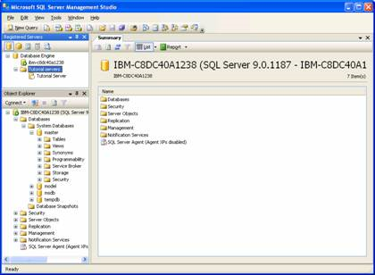

To **remove** a server group or a server, right click on the selected server name or server group name, click **Delete**, and in the confirmation dialog box click **Yes**.

1. **Introduction to Database**

What is database and DBMS?

Database is a shared collection of logically related data, and a description of this data, designed to meet the information needs of an organization (Connolly & Beg, 2010:15). A software system that enables users to define, create, maintain and control access to the database is called DBMS *(Database Management System)* (Connolly & Beg, 2010:16).

The following picture is the database hierarchy:

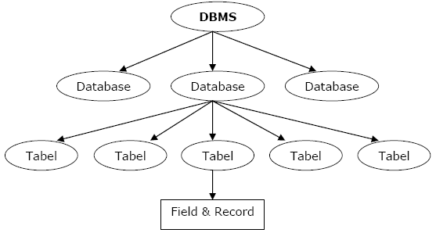

**What is view?**

View often called as a virtual table. A view contains a query on one or more base relations (tables). View are dynamic, it means that every changes made to the base relations (tables) that affect the view are immediately reflects the view. View provides a powerful and flexible security mechanism by hiding parts of the database from certain users.

**What is stored procedure?**

Stored procedure is one of subprograms named PL/SQL blocks that can take parameter and be invoked. Stored procedure provide modularity and extensibility, promote reusability and maintainability and aid abstraction.

**What is users?**

Users is a login identity when its connected to database. A user is a database level security principal, premissions can be granted to users.

To create a new user, do the following steps:

1. Right click on **Security** tree, chooose **New**, and then click **Login**.

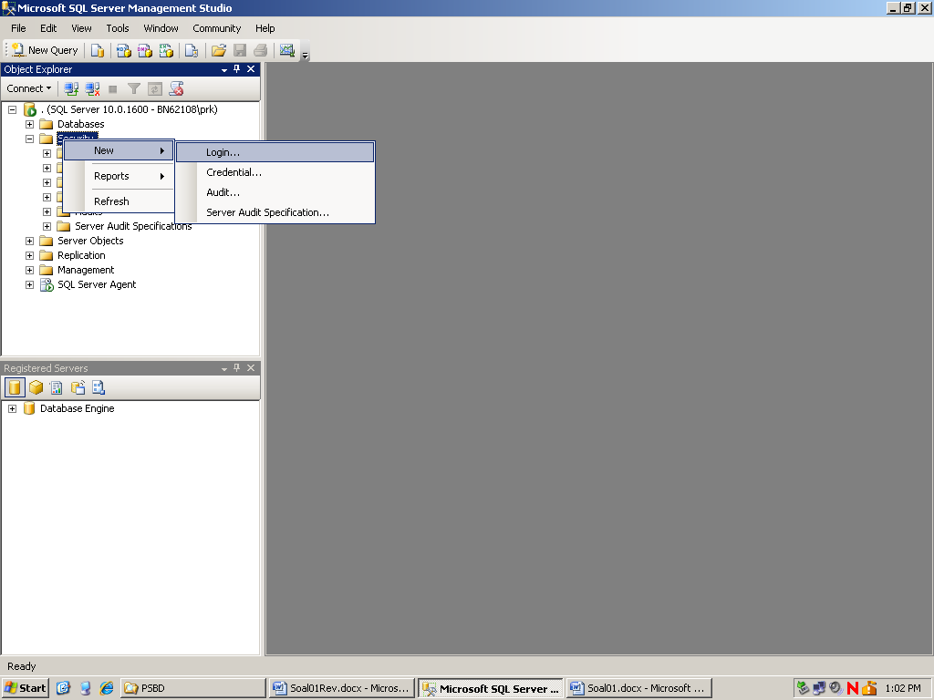

1. In the **Login-New** dialog box, on the **General** tab type the name of the new user in the **Login name** box.
2. There are two types of authentication, **Windows authentication** and **SQL Server authentication**. If you want to create a login based on a Window principal, select Windows authentication. If you want to create the login that is saved on a SQL Server database, select SQL Server authentication.
   * + - **Password**, this option only enables if you select the SQL Server authentication. Type a password for the new user. Type that password again into the **Confirm Password** box.
       - **Enforce password policy**, this option only enables if you select the SQL Server authentication. Select this option if you want to enforce password policy for complexity and enforcement.
       - **Enforce password expiration**, this option only enables if you select the SQL Server authentication. Select this option to enforce password for expiration.
       - **User must change password at next login**, this option only enables if you select **Enforce password expiration**. Select this option to force user to create a new password after the first time login is used.
3. **Mapped to certificate**, select this option and select the name of an existing certificate from the list to associate the login with a stand-alone security certificate.
4. **Mapped to asymmetric key**, select this option and select the name of an existing key from the list to associate the login with a stand-alone asymmetric key.
5. **Mapped to credential**, select this option to associate login with a security credential.
6. From the default database list, select a default database for the login.
7. From the default language list, select a default language for the login.

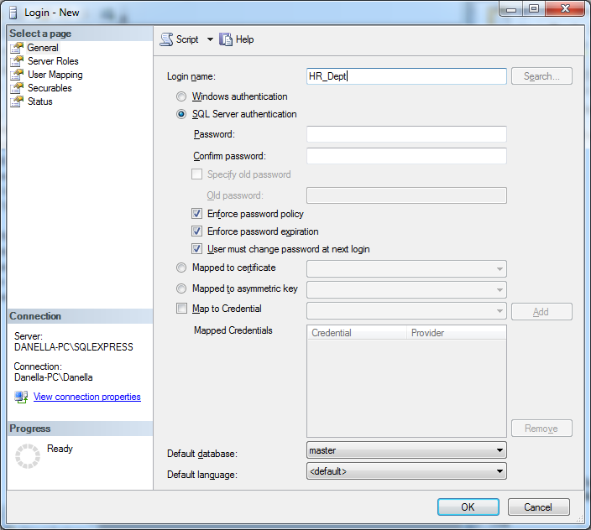

1. The **Login-New** dialog box also offers options on additional page they are: **Server Roles**, **User Mapping**, **Securable**, and **Status**.
   * + - **Server roles**, this page allows us to set role for the new login. The following table describes several types of server roles:

|  |  |
| --- | --- |
| **Server Roles** | **Description** |
| **bulkadmin** | Server role can run the BULK INSERT statement.  *Authorization*:  BULKINSERT |
| **dbcreator** | Server role can create, alter, drop, and restore any database.  *Authorization*:  CREATE DATABASE, ALTER DATABASE, DROP DATABASE, RESTORE DATABASE, sp_renamedb |
| **diskadmin** | Server role can manage disk files.  *Authorization*:  DISK INIT, sp_addumpdevice, sp_diskdefault, sp_dropdevice |
| **processadmin** | Server role can terminate processes running in an instance of the Database Engine.  *Authorization*:  KILL |
| **public** | Server role belong to the public. |
| **securityadmin** | Server role can manage logins and their properties. They can GRANT, DENY, REVOKE on the server-level and database level permissions.  *Authorization*:  sp_addlogin, sp_password, sp_droplogin, sp_denylogin, sp_defaultdb |
| **serveradmin** | Server role can change server-wide configuration options and shut down the server.  *Authorization*:  RECONFIGURE, SHUTDOWN, sp_configure, sp_fulltext_service |
| **setupadmin** | Server role can add and remove linked servers and execute some system-stored-procedures. |
| **sysadmin** | Server role can perform any activity in the Database Engine.  *Authorization*:  CREATE DATABASE, ALTER DATABASE, DROP DATABASE, REVOKE, GRANT |

* + - * **User Mapping**, this page lists all databases that can be applied to the login. Select the database that can be accessed by this login.
      * **Securable**, this page lists all securable and permission that can be granted to the login.
      * **Status**, this page lists some authentication and authorization options that can be configured to the login.

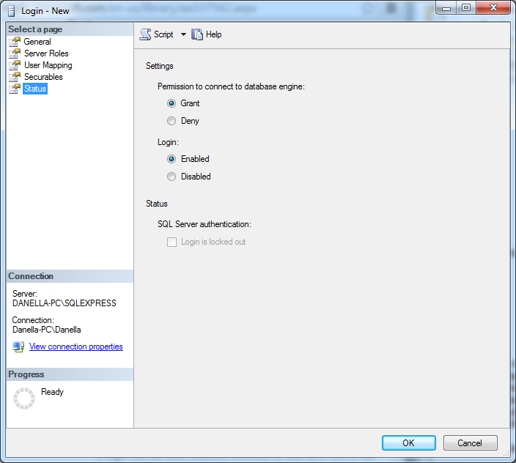

1. Click **OK** button to complete the steps.

**What is role?**

Role facilitates us to group users so it can be managed easily. Any changes in roles’ permission will reflect to all users that are grouped in that role.

There are some syntax that can be used in manipulating role:

**sp_addlogin** login_id [, password [, database]]

*To create new login account in SQL Server*

E.g.:

EXEC sp_addlogin Margaret, Rose

**sp_droplogin** login_id

*To remove a login account from SQL Server*

E.g.:

EXEC sp_droplogin 'Victoria'

**sp_password** old_password new_pasword login_id

*To modify login password*

E.g.:

EXEC sp_password 'ok', 'coffee'

**sp_defaultdb** login_id database_name

*To change the database default for that login*

E.g.:

EXEC sp_defaultdb 'Victoria', 'pubs'

**sp_addrole** [@rolename=] 'role'  [ , [ @ownername=] 'owner' ]

*To create a new role*

E.g.:

EXEC sp_addrole 'Managers'

**sp_droprole** [@rolename**=**] **'**role**'**

*To remove a role*

E.g.:

EXEC sp_droprole 'Managers'

1. **Attach and Detach Database**

One of the methods to distribute, copy, and create a database backup in SQL Server is by using, attach and detach option. Database in SQL Server has two file types, main file that formatted in (.mdf) and logfile that formatted in (.ldf).

To **attach a database**, do the following steps:

1. Right click on **Database** tree and click **Attach..**

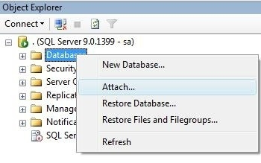

1. On **Attach Databases** dialog box, click **Add** button to choose (.mdf) file from a database. This action will automatically added databases’ log file on the detail panel. After you complete this steps, click **OK** button.

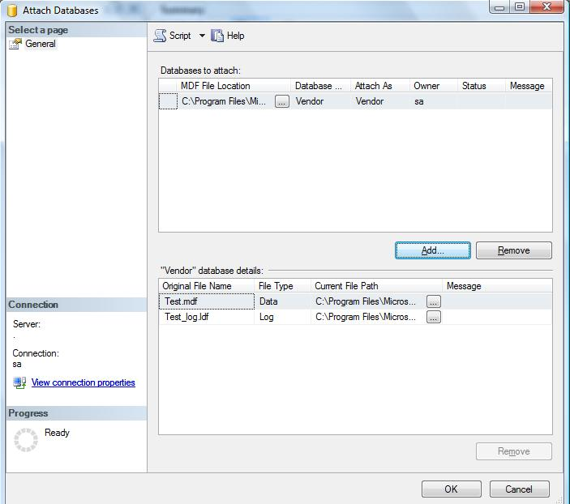

To **detach a database**, right click on selected database tree, choose **Task** menu and then click **Detach**. On **Detach Database** dialog box click **OK** button.

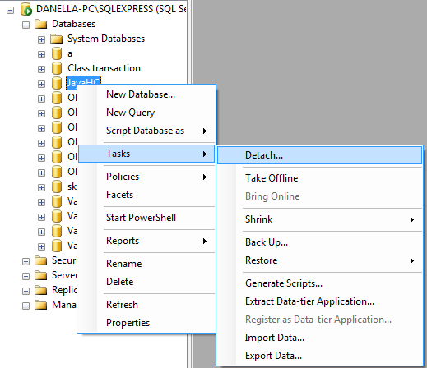

After a database detached, you can distribute or create a backup from that database. You should attach that database before you use it.

1. **Import and Export Data**

To **export a database**, do the following steps:

1. Right click on the selected database tree, choose **Tasks** menu, and then click **Export Data**.
2. In **SQL Server Import and Export Wizard** welcome dialog box, click **Next** button.
3. In data source properties, set **Data Source**, **Server Name**, **Authentication**, and **choose database** that you want to export. After completing this setting, click **Next** button.

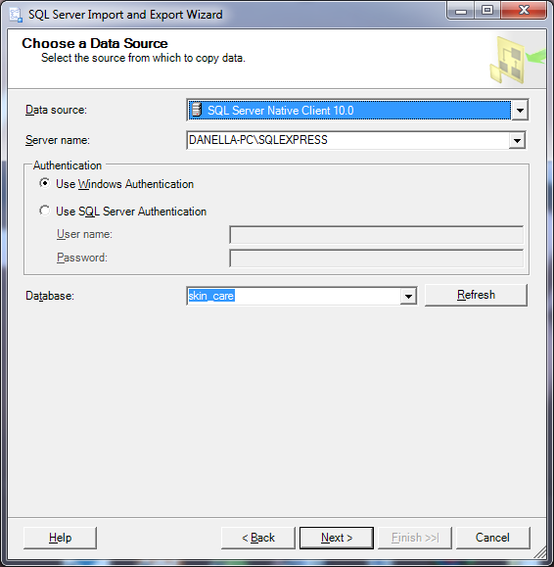

1. In destination properties, set Destination (as an example chooses Microsoft Excel), choose where the Excel file resides by click **Browse** button, choose Excel version, and then click **Next** button.

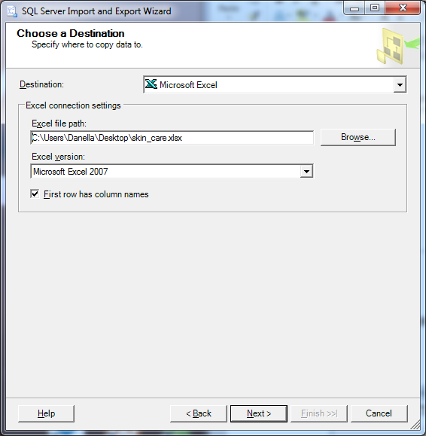

1. In the **Specify Table Copy or Query** page, there are two types of copy operation: **copy all existing data** and **write a query**. After choosing one of those options, click **Next** button.

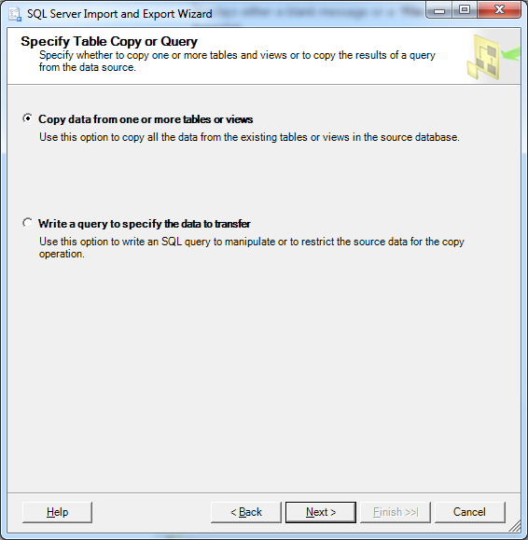

1. In the **Source Tables and Views** page, choose table that you want to export. After completing this steps, click **Next** button.

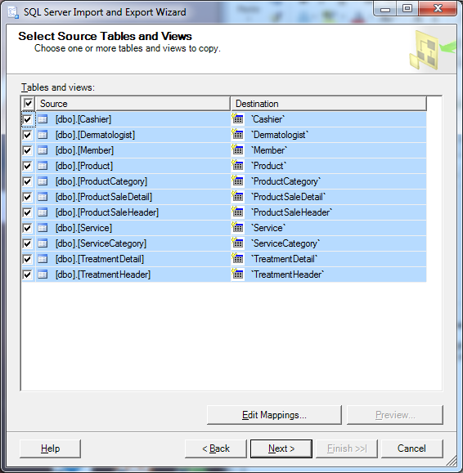

1. In **Review Data Type Mapping** page, change **On Error** and **On Truncation** option into **Ignore**. After completing this steps, click **Finish** button.
2. To complete export these database, click **Finish** button.

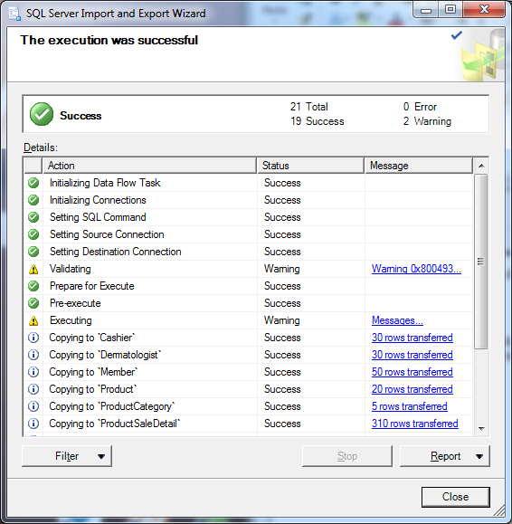

1. After data exported successfully, you will be able to see all data in excel.

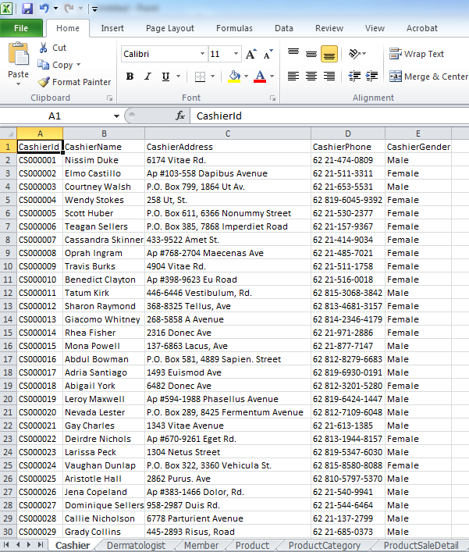

To **import a database**, do the following steps:

1. Right click on the selected database tree, choose **Tasks** menu, and then click **Import Data**.
2. In the **Data Source** properties, set Data Source (as an example chooses Microsoft Excel), choose where the Excel file resides by click **Browse** button, choose Excel version, and then click **Next** button.

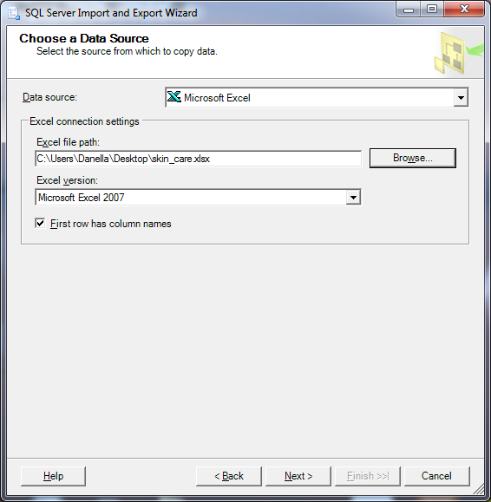

1. In the destination properties, set **Destination** (as an example chooses SQL Server Native Client 10.0), **Server Name**, **Authentication**, and **Database**.

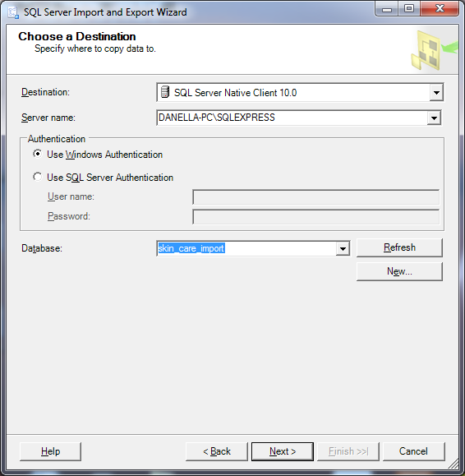

1. In the **Specify Table Copy or Query** page, there are two types of copy operation: **copy all existing data** and **write a query**. After choosing one of those options, click **Next** button.
2. In the **Source Tables and Views** page, choose table that you want to import. After completing this steps, click **Finish** button.

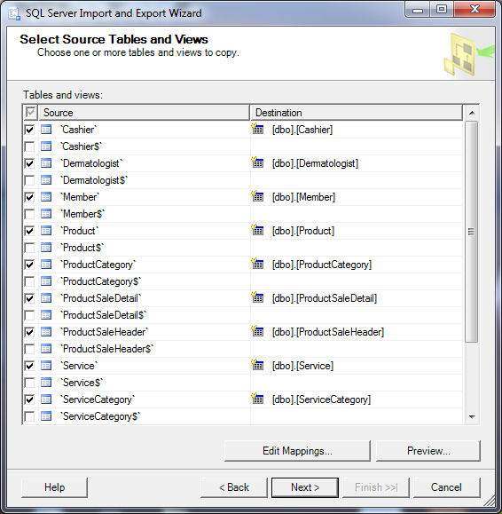

1. After excel file imported successfully, now you can see the table in seleceted database has been create by importing an excel file.

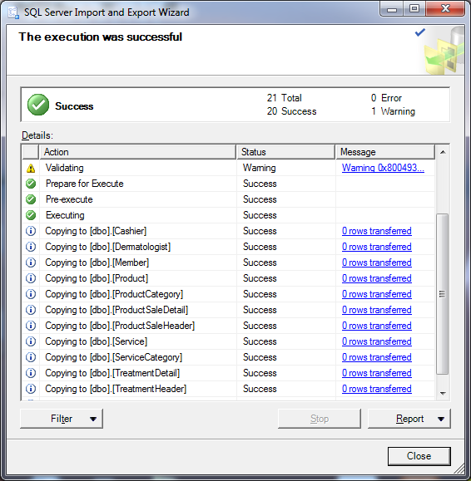

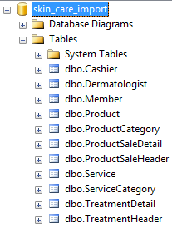

1. **Backup and Restore Database**

To **back up a database**, do the following steps:

1. Right click on the database that you want to backup, choose **Tasks** menu and then click **Back Up** menu.

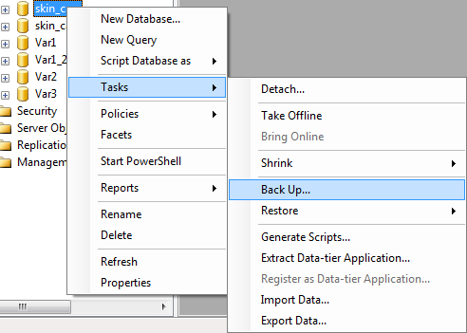

1. On the Destination section, click **Add** button.

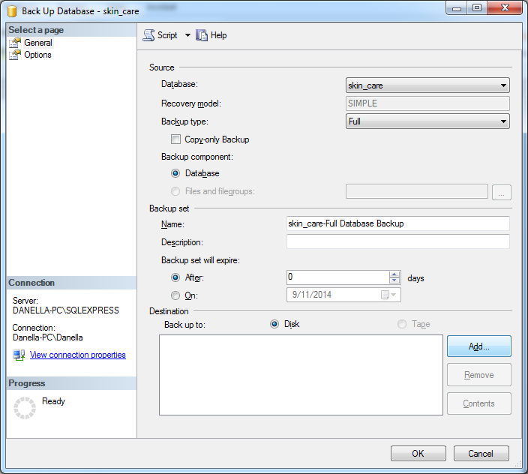

1. On the **Select Backup Destination** window, click browse button to choose the directory of the backup files.

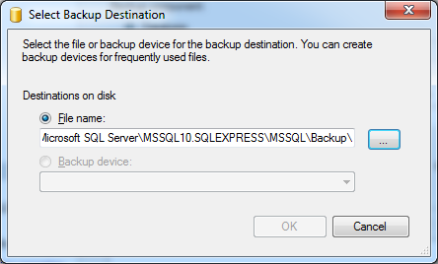

1. Choose the path and fill the **File name** of the backup file, and then click **Ok** button.

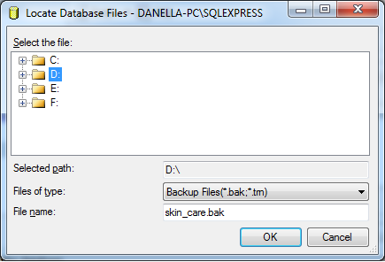

1. After completes the settings, click **Ok** button.

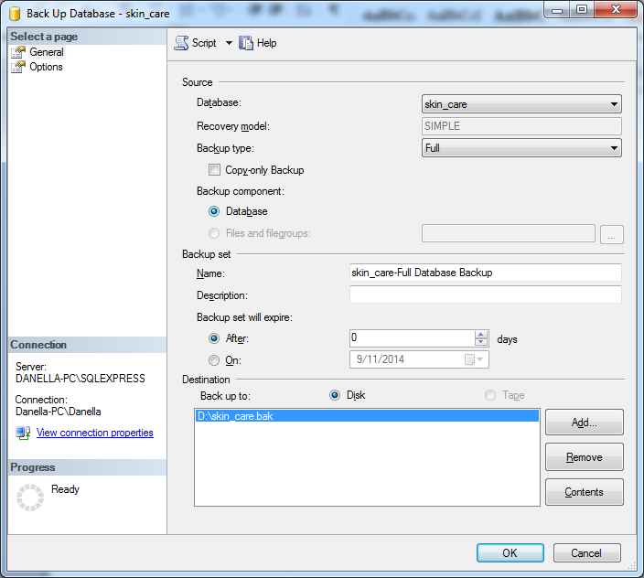

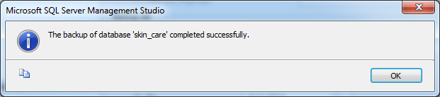

To **restore a database**, do the following steps:

1. In the Object Explorer, right click on the **Databases** option and then click **Restore Database** menu.
2. On the Restore Database window, on the source section choose source **From Device** and then click the Browse button.

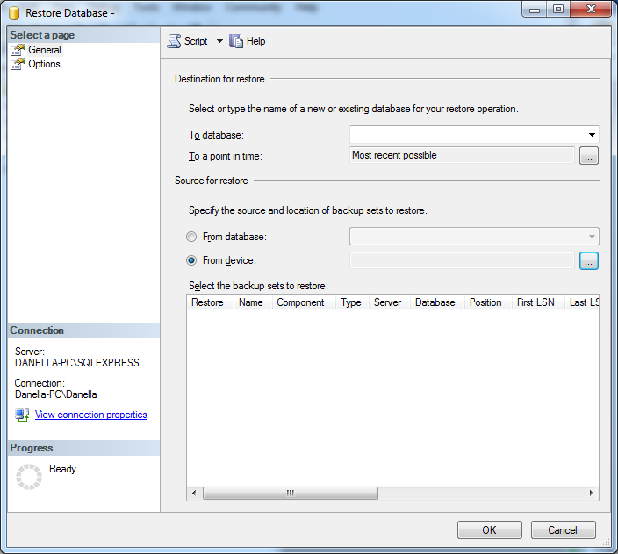

1. On the **Specify Backup** dialog box, click **Add** button to search the backup file, choose the backup file on the **Locate Backup File** dialog box and then click **OK** button.

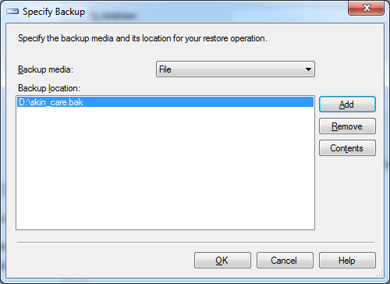

1. On the **Restore Database** dialog box, check the backup file to restore and choose database destination by change the value of **To database** option.

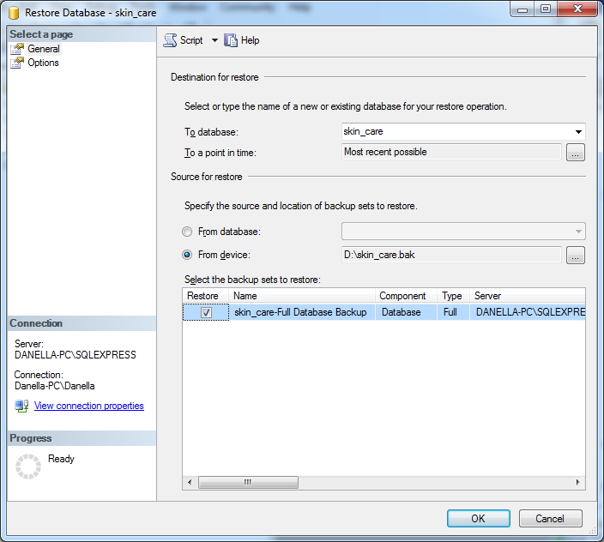

1. After completes the settings, click **OK** button.
2. **SQL Query Analyzer**

# Query Analyzer is graphical tool on Microsoft SQL Server that can perform below operations:

* 1. Create database
  2. Manipulates and connect to other databases
  3. Provide remote data access (RDA) and replication
  4. Create and modify table and index on database
  5. Display query objects using select statement
  6. Insert and delete data on the tables
  7. Modify the existing table
  8. Repair the database

1. **Execution SQL Statement**

To create new query in Management Studio, choose **New Query** menu on the upper left corner of the window.

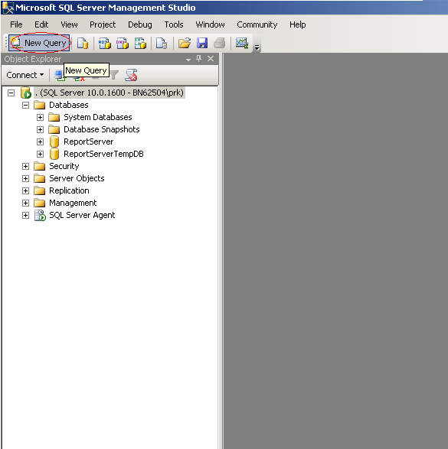

To execute a statement that we made, click **Execute** option or press **F5.**

**References:**

<http://msdn.microsoft.com/en-us/library/>

**If you don’t understand, please ask your assistant**!